Workplace Edge – Bridge Across Roles

Facilitator Notes (Required)
Delivery Mode: Hybrid (self-paced with optional live group coaching)
Session Length: 50–60 minutes
Facilitator Role: Help learners explore how language can reduce silos and strengthen cross-functional collaboration. Use reflection, practice, and behavioural nudges to support learning.

1. Welcome & Introduction (5 minutes)
Script: "Welcome. Today’s lesson is Bridge Across Roles. It’s about how we move from working in silos to working in sync. You’ll learn language that helps connect perspectives, especially across departments or functions." Encourage learners to bring real examples from their own work.
This lesson also touches on how to adapt your language to suit different contexts while staying aligned to your collaborative intent.

2. Spark (10 minutes)
Display or read the Spark section. Prompt solo reflection:
- "Think of a time when a project was slowed down because of siloed decision-making. What could have been done differently?"
- "Which function do you usually align with least? What’s one question you’ve never asked them?"

3. Shift (25 minutes)
Read the transcript (from above including mini dialogues) aloud or allow silent reading. Then:
- Display the bridging phrases.
- Ask learners to choose one phrase and apply it to a real scenario.
- Optionally, invite paired practice (live or async) using the phrases in mock meetings.
Cross-functional work can trigger emotion, especially if past misalignment led to rework, confusion, or blame. Invite learners to pause and notice any frustration or assumptions they carry into these interactions. Naming that emotion (even just to yourself) can help shift from defensiveness to curiosity.
Consider showing a quick model of a bridging phrase in action using a short script or paired role play. This helps build comfort and fluency. You can use the mini-dialogue provided in the Shift section or have participants co-create one.
Encourage learners to adapt the bridging phrases into their own voice. You can say: ‘What’s a version of this phrase that you would actually say in your next meeting?’ Then compare it to the original.
Even if your bridging attempt feels clumsy, the effort to connect is what makes the difference.
Facilitator prompt for async delivery:
"After practising your bridging phrase, take a moment to reflect:
- Did your tone sound sincere or hesitant?
- Was it too formal or too casual for your team’s culture?
- Which bridging phrase felt easiest or hardest to say? Why?
- Did you reword any of the phrases? How did you keep the meaning the same?
- Try recording yourself saying the phrase and play it back. What could you adjust to sound more curious and inclusive?
Remind learners that tone matters as much as words, especially when working across functions or roles that may interpret intent differently.
If learners are completing this lesson solo, encourage them to revisit the model bridging phrases. Suggest they listen or re-read one aloud before applying it in their own scenario. This reinforces tone awareness and builds fluency.
Pacing guidance: This task can be done in 10–15 minutes, or extended for journaling or more detailed scenario planning.
Optional async alternative for group sharing: If using a shared platform (like a forum, Slack channel, or learning portal), invite learners to:
- Post a draft bridging phrase they might use in an upcoming meeting.
- Reply to one peer’s post with a short summary: “How does this phrase invite collaboration or connection?”
Optional Peer Reflection (Live Delivery or Async):
Invite learners to pair up and share a time when cross-functional alignment succeeded—or failed. Prompt them to reflect on:
- What helped or hindered collaboration?
- What bridging phrase might have helped in that situation?
- How might they use language differently next time?
This peer sharing can happen live in breakout rooms or asynchronously using written prompts in shared documents or message boards. For global teams, encourage learners to compare how collaboration works in their cultural context. Ask: “What’s the norm in your culture, consult widely or decide fast? How does that affect how you bridge?”
Facilitator Tip: If learners work in hierarchical or fast-paced environments, remind them that bridging language doesn’t mean slowing everything down, it means being intentional about when and how they include others.
Model different ways to adapt your phrasing based on the setting. For example, your language might shift depending on the level of hierarchy, level of formality, or the function you’re speaking with. Matching tone to context helps you stay inclusive and build credibility with your cross-functional partners, without losing the bridging impact.

4. Stretch (15–20 minutes)
Ask learners to identify one cross-functional moment coming up. Invite them to:
- Use a bridging phrase during the interaction
- Reflect afterwards using the questions provided
Best Practice Tip: Preparing to Bridge in a Meeting - To make the most of this opportunity and avoid common pitfalls of cross-functional discussions, like siloed updates, role confusion, or missed context (meetjamie.ai), prompt learners to:
- Clarify the purpose. Is the goal information sharing, discussion, or a decision?
- Check who's in the room. Is every impacted function represented? If not, note whose lens might be missing.
- Prepare a bridging question in advance. For example:
“How might your team view this risk differently?” or “Would this timing create barriers for your side?”
- Set tone early. Frame the meeting with an inclusive intent: “Let’s align views before we move on.”
- End the meeting with shared commitment: “Have we considered all functional perspectives before we decide?”. This helps reinforce shared ownership, especially in complex or matrixed teams
Optional follow-up prompts:
- "What happened when you brought in a new perspective?"
- "Did this change your view of their role or yours?"
Optional Debrief Guidance (for live sessions):
If a learner shares that their bridging attempt felt awkward or didn’t land well, validate the effort and normalize the challenge. Try prompts like:
- “What do you think made it feel awkward?”
- “What might you try differently next time?”
- “Even when it’s clumsy, trying to bridge roles shows intent—and that matters.”
Emphasize that this is a skill that builds over time through practice, tone refinement, and trust-building. It’s okay if this feels clunky or unfamiliar. Many of us aren’t used to explicitly inviting cross-functional input. What matters is that you’re trying, progress comes from practice, not perfection.
Optional follow-up discussions or journaling questions related to:
- Empathy: “What might this look like from the other person’s perspective?”
- Social awareness: “How does my function’s communication style affect others?”
- Relationship skills: “How can I use language to build trust between roles?”
This language shift can unlock faster alignment, stronger collaboration, and more inclusive decisions.

7. References (APA format)
Bolman, L. G., & Deal, T. E. (2017). Reframing organizations: Artistry, choice, and leadership (6th ed.). Jossey-Bass.
Meyer, E. (2014). The culture map: Breaking through the invisible boundaries of global business. PublicAffairs.
Meier, J. D. (2025). High performance. Innovation. Leadership. JD Meier. https://jdmeier.com/
McKinsey & Company. (2022). Tearing down silos to boost performance. Retrieved from https://www.mckinsey.com/business-functions/organization/our-insights/the-organization-blog/tearing-down-silos-to-boost-performance

8. Glossary
Cross-functional Collaboration - Working together across different departments (like Marketing, Finance, or Operations) to reach a shared goal.
Silo Mentality - When teams or departments work in isolation and don’t share information or ideas with others.
Bridging Phrases - Short, respectful questions or statements that help connect people from different teams or roles.
Perspective-Seeking - Asking others how they see a situation—especially when they work in a different team or role.
Alignment - Making sure everyone understands the plan, agrees on it, and is working toward the same goal.
Consensual Decision-Making - A decision process that involves hearing from everyone and agreeing as a group before moving forward.
Functional Lens - The specific way a team sees things, based on its area of work (for example, Finance vs. Design).
Psychological Safety - A team climate where people feel safe to speak up, ask questions, and share ideas or concerns without fear of embarrassment or punishment.
Sidelined - When someone feels left out of a conversation, decision, or activity, like their input isn’t being considered or included.
Sense check - A quick way to confirm that something is on the right track by getting someone else’s input. Common in UK workplaces; similar to a “check-in” or “confirmation” elsewhere.
Stay in your lane - A phrase often used to remind individuals to stay focused on their own responsibilities or areas of expertise, avoiding unnecessary involvement in others’ roles. While it can be helpful for maintaining accountability and workflow clarity, overuse or misuse of this phrase can shut down curiosity, collaboration,
Check list visual for practice tasks
Checklist icon to support practice task comprehension for visual learners
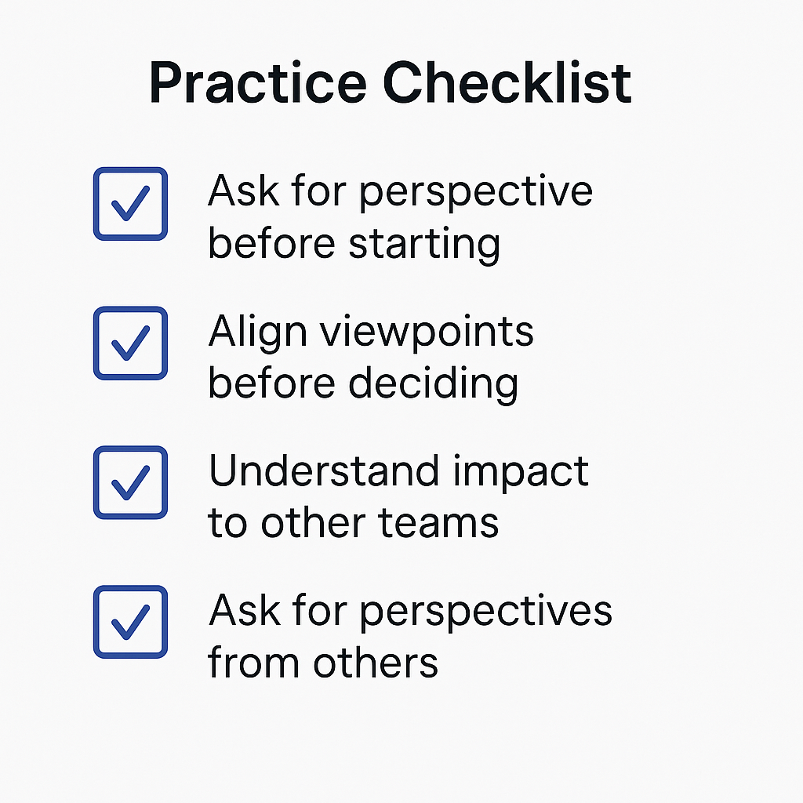

Bridging Phrase Cheat Sheet
Prompts to connect across teams, clarify assumptions, and align before making decisions.

💬 Perspective-Seeking
Use when you want to understand how others see the situation.
- “What’s your perspective from where you sit?”
- “How does this land with your team?”
- “What would this look like from your role?”

🤝 Pre-Decision Alignment
Use to connect views before moving forward.
- “Let’s align our views before we decide.”
- “Are there any considerations we haven’t covered yet?”
- “Before we finalise, I want to sense check with [team/function].”

🛠 Clarifying Roles & Impacts
Use when navigating dependencies or responsibilities.
- “How does this impact your team’s priorities?”
- “Is there anything your function would flag before we move on?”
- “Can you see any knock-on effects we should plan for?”

🌍 Cultural & Hierarchical Adaptations
Use when working across authority levels or international teams.
- “Would it be helpful to consider how [function] sees this?”
- “I’d love to hear your thoughts from a [team] angle, if you’re comfortable sharing.”
- “We’ve made a draft decision, but want to include [team’s] view before closing it out.”

🧠 Tone Tips
Make it yours, rephrase for natural tone and sincerity. If your first language is different or you tend to speak more formally, adjust the bridging phrases to sound natural in your voice. It’s not about the exact words, it’s about your intent to connect.
- Keep it curious, not controlling.
- Match your team’s communication style (formal/informal).
- If it sounds too stiff or scripted, try:
“Here’s what I’m thinking… does your team see it the same way?”
Bridging Across Roles in Meetings
Purpose: Help teams use meetings to break down silos and invite perspective-sharing across departments.
Usable in: Hybrid, remote, or in-person settings
When to Use This:
- Project kickoffs
- Weekly status meetings
- Decision reviews
- Huddles with cross-functional input
- Stakeholder alignment
Designed to build SEL skills: social awareness, communication, empathy, and responsible decision making.
Meeting Flow: From Silos to Shared Ownership
1. OPENING THE MEETING (5 minutes)
Purpose: Set tone, name functions present, encourage curiosity
Sample phrase (for host or facilitator):
- “Let’s start by acknowledging we’ve got [teams listed] in the room. That gives us a full picture from strategy, design, delivery, and support.”
- “Before we dive in, let’s take a quick look at how today’s decision could impact your team’s area. I’ll ask each voice in the room to weigh in at key points.”
💡 Tip: Reaffirm the shared goal. E.g., “We’re here to move faster and more aligned—thanks, everyone, for bringing your lens to the table.”
—
2. MID-MEETING: INVITING PERSPECTIVES (Core Agenda Items)
For each agenda item, build in functional check-ins. Use bridging phrases to surface views early.
STRUCTURE:
Topic raised → Host summarizes → “Let’s bridge” prompt → Clarify → Then move forward
Sample bridging language:
- “What would this look like from the [Ops/Finance/Customer Success] side?”
- “Do we see any dependencies this decision might create?”
- “Before we finalise, let’s align across roles. Are there any impacts we haven’t considered yet?”
- “Any views on this from where you’re sitting?”
Watch for silence. Prompt: “Who haven’t we heard from yet, and what might their function pick up downstream?”
—
3. CLOSING THE MEETING (Last 5–7 minutes)
Goal: Reconfirm shared understanding, clarify ownership, and reinforce alignment
Sample wrap-up script:
- “Here’s what we’ve aligned on—and what each team is taking forward…”
- “Quick sense check—do we all feel clear on how this impacts our team’s next steps?”
- “Let’s turn this into a simple recap so we can track progress across functions next week.”
OPTIONAL: Try the final alignment prompt:
- “If another team walked in right now and asked what we decided, would we all answer the same way?”
—
Sample Meeting Agenda: Cross-Functional Sync (for use with lucidmeetings.com)
- Welcome & cross-functional check-in
- Agenda overview
- Review of blockers, with bridging language
- Aligned action review
- Close with impact reframe and function check
—
"Bridging across roles doesn’t begin with consensus, it begins with curiosity. Every well-run meeting is a chance to rehearse inclusion.”

When Bridging Meets Resistance: What to Do Next
Purpose: This resource helps learners navigate common roadblocks when trying to use bridging language. It offers calm, professional strategies for responding to resistance, silence, or pushback, especially in situations where cross-functional teams are guarded, skeptical, or overloaded.
🧭 Why This Matters
Bridging language is powerful, but it doesn’t always land the first time. People might:
- Be too busy to engage
- Feel like “input” doesn’t mean influence
- Assume their role isn’t relevant
- Resist because they’ve been burned by misalignment in the past
If someone says no, stays silent, or deflects your effort to collaborate across roles, it doesn’t mean the door is closed, it just means you may need to try again differently.
These strategies strengthen emotional intelligence skills like:
- Self-awareness (managing reactions to rejection or discomfort)
- Empathy (understanding why someone may hesitate)
- Relationship skills (building trust and shared respect over time)
COMMON FORM OF RESISTANCE & WHAT TO TRY IN RESPONSE
(1) THE HARD “NO”: “That’s not our priority.” or “We’ve already decided.”
Try this:
- “I hear that. What would make this more relevant to your team?”
- “Would it be okay if I followed up after [event or deadline]? I think insight from your function could help us avoid rework.”
Tip: Acknowledge their busy context and ask permission to keep the loop open.
(2) SILENCE or “We’re good”: No input offered when you bridge.
Try this:
- “I noticed we didn’t get a view from [team]. Is there anything that might create a tension point for your function later on?”
- “I want to make space for your view, even if it’s a quick one. Is there anything you'd want us to understand from your side?”
Tip: Make it low-stakes, but signal genuine interest in perspective.
(3) “STAY IN YOUR LANE” FEEDBACK: “This isn’t in your scope.”
Try this:
- “I completely respect your role boundaries. I’m asking because collaboration is smoother when we see the big picture. Would you be open to just a quick sense check to help me understand how this lands with your area?”
Tip: Reframe your curiosity as efficiency—not control.
(4) INDIRECT RESISTANCE: Deflecting the invite: “Let’s circle back later.” or “We’ll let you know.”
Try this:
- “Thanks for noting that. So I can plan well, is there a better time or condition for your team to weigh in?”
- “If later’s better, I’ll mark a follow-up. I want to make sure your team’s needs are in the mix.”
Tip: Be gracious, signal accountability, and follow through.
ADVANCED BRIDGING STRATEGIES
- Enlist a Trusted Connector - If you’re external to the team, ask a respected team member to relay or endorse your bridging approach. This builds relational credibility through peer support.
Say: “Would it land better if someone closer to the team introduced the question?”
- Use a Bridge-by-Example - Sometimes, showing the value of bridging indirectly helps. Share a story about when cross-role misalignment created confusion and what changed when someone paused to check impact.
Say: “We’ve seen projects drift when a team wasn’t looped in early. I’m hoping to prevent that here.”
- Normalize Resistance - If there’s clear tension or a history of being siloed, acknowledge it.
Say: “I know people are stretched and bridging roles hasn’t always been the norm. I’m trying to shift that gently, one question at a time.”
- Reframe the Goal - You’re not trying to “get everyone to say yes”. You’re building a habit of inclusive dialogue, whether or not there’s agreement. This isn't about control or consensus. It’s about:
- Helping each role feel seen
- Reducing future rework
- Creating shared direction
Final Encouragement: Being the person who keeps inviting others in, even gently, even when it’s awkward, is a leadership act. Bridging takes courage, consistency, and humility.
Want to Practice? Pair this tool with these practice prompts from the main lesson:
- “Let’s align our views before we decide.”
- “What might this look like from your end?”
- “Can you see any tensions we should know about?”
- Try 1 bridging question with someone outside your function this week, even if they’ve said “no” before.
Add to Your Learning Journal:
- What happened?
- How did they respond this time?
- How did you feel while asking?

